SQL PRACTICE SET – RETAIL EVENTS DATASET
20 QUESTIONS | EASY → MEDIUM → HARD

DATASET OVERVIEW
================

This practice set uses the retail_events_db database.

Main tables:

1. dim_campaigns
- campaign_id
- campaign_name
- start_date
- end_date

2. dim_products
- product_code
- product_name
- category

3. dim_stores
- store_id
- city

4. fact_events
- event_id
- store_id
- campaign_id
- product_code
- base_price
- promo_type
- quantity_sold(before_promo)
- quantity_sold(after_promo)

The fact_events table stores product-level promotional event information.
Use the dimension tables to obtain campaign, product and store details.

IMPORTANT:
- Use MySQL syntax.
- Column names containing parentheses may need backticks.
Example:
`quantity_sold(before_promo)`
`quantity_sold(after_promo)`
- Do not modify the data.
- Write a separate SQL query for each question.
- Questions are arranged from easy to hard.
- Focus especially on JOINs, GROUP BY, HAVING, CASE, CTEs and window functions.

============================================================
EASY QUESTIONS
============================================================

Q1. Basic Filtering – High-Value Products
Find all event records where the base_price is greater than 1,000.

Display:
- event_id
- store_id
- product_code
- base_price
- promo_type

Concepts:
SELECT, WHERE, comparison operators.

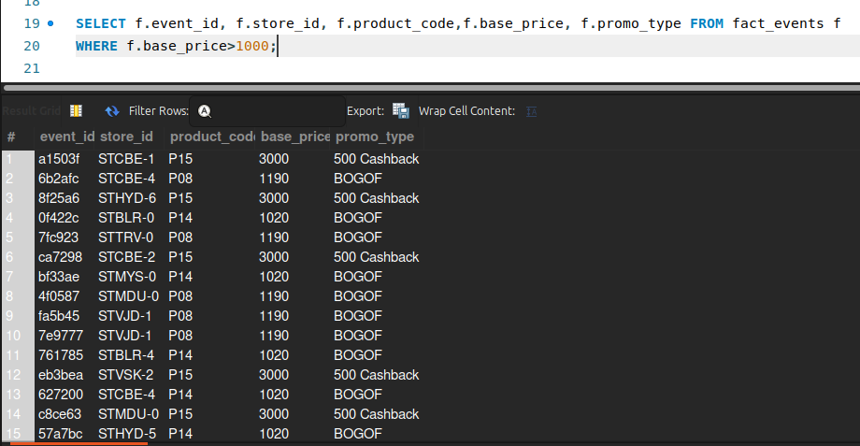

------------------------------------------------------------

Q2. Sorting Promotional Events
Display all events where quantity sold after the promotion was greater than 100.

Display:
- event_id
- product_code
- promo_type
- quantity_sold(before_promo)
- quantity_sold(after_promo)

Sort by quantity_sold(after_promo) in descending order.

Concepts:
WHERE, ORDER BY, DESC.
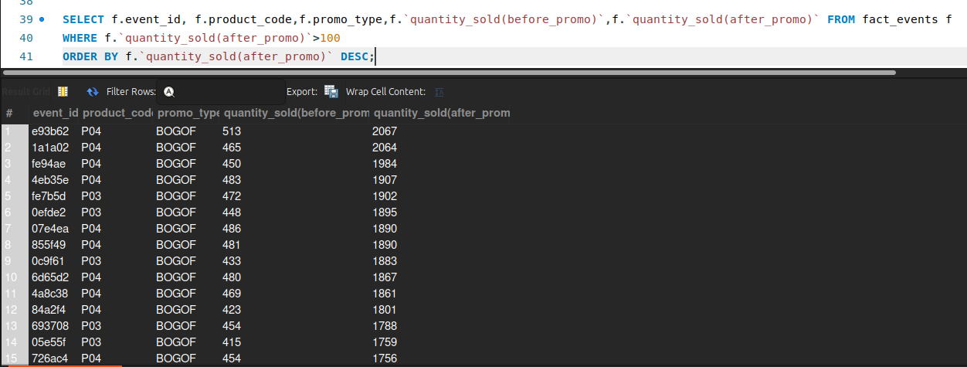
------------------------------------------------------------

Q3. DISTINCT Promotion Types
Find all unique promotion types used in the dataset.
Display only the unique promo_type values.

Concepts:
DISTINCT.
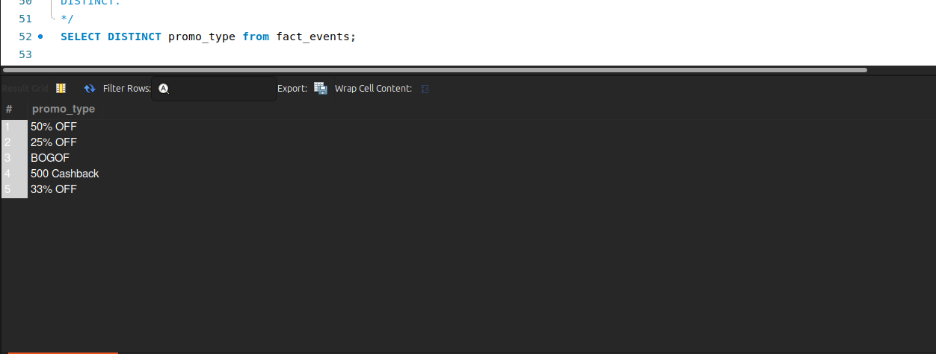
------------------------------------------------------------

Q4. Basic Aggregation
Calculate the following for the complete fact_events table:

- Total number of events
- Total quantity sold before promotion
- Total quantity sold after promotion
- Average base price
- Maximum base price
- Minimum base price

Return all metrics in one row.

Concepts:
COUNT, SUM, AVG, MAX, MIN.

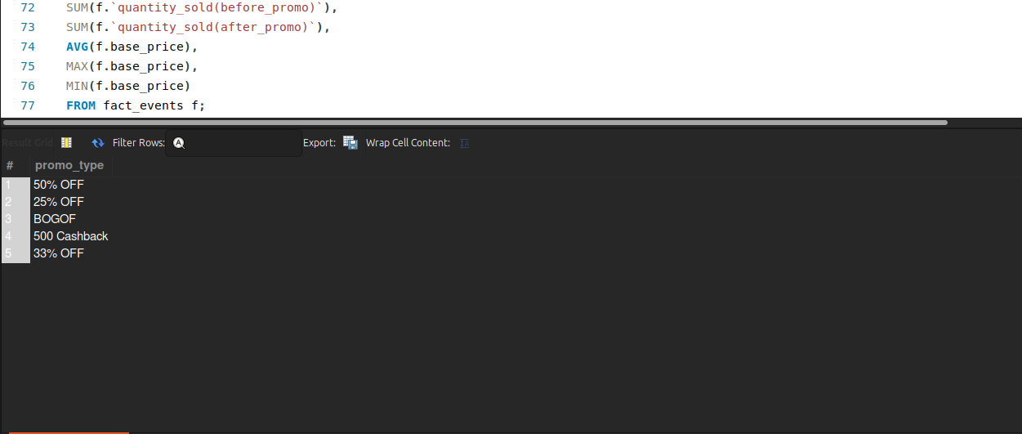

============================================================
MEDIUM QUESTIONS
============================================================

Q5. Sales Volume by Promotion Type
For each promo_type, calculate:

- Number of events
- Total quantity sold before promotion
- Total quantity sold after promotion

Sort by total quantity sold after promotion in descending order.

Concepts:
GROUP BY, COUNT, SUM, ORDER BY.
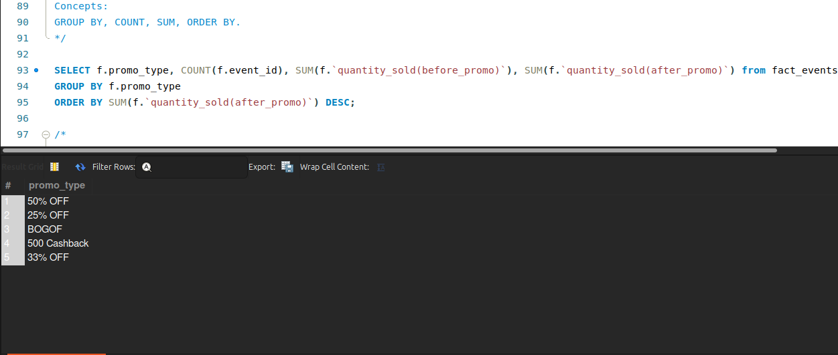

------------------------------------------------------------

Q6. Promotion Uplift
For every promotion type, calculate:

- Total quantity before promotion
- Total quantity after promotion
- Quantity increase/decrease

Use:

Quantity Change = After Promo Quantity - Before Promo Quantity

Display:
- promo_type
- total_before
- total_after
- quantity_change

Sort by quantity_change descending.

Concepts:
GROUP BY, SUM, arithmetic calculations, aliases.
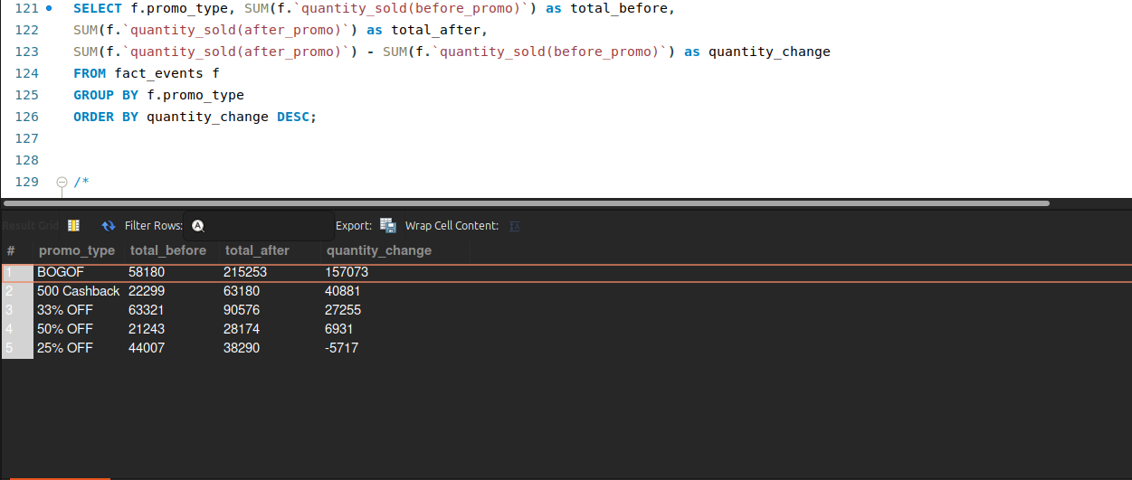
------------------------------------------------------------

Q7. Product Performance
Using fact_events and dim_products, calculate total quantity sold after promotion for every product.

Display:
- product_code
- product_name
- category
- total quantity after promotion

Sort by total quantity after promotion descending.

Concepts:
INNER JOIN, GROUP BY, SUM, ORDER BY.

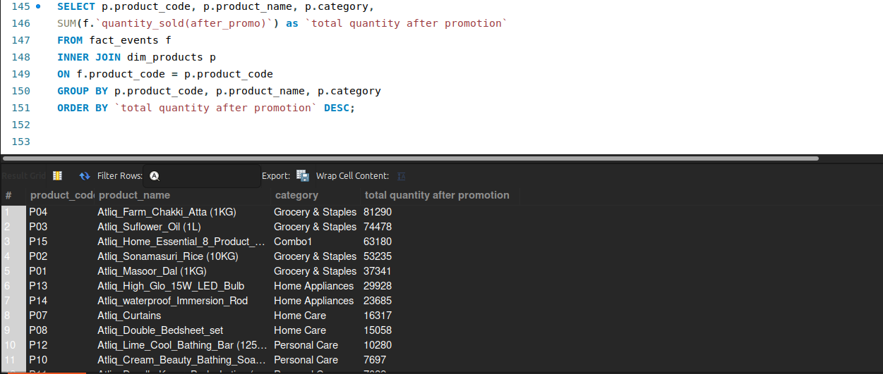

------------------------------------------------------------

Q8. Category-Level Performance
Using fact_events and dim_products, calculate for every product category:

- Number of events
- Total quantity before promotion
- Total quantity after promotion
- Quantity change

Sort categories by total quantity after promotion descending.

Concepts:
JOIN, GROUP BY, SUM, COUNT, arithmetic calculations.
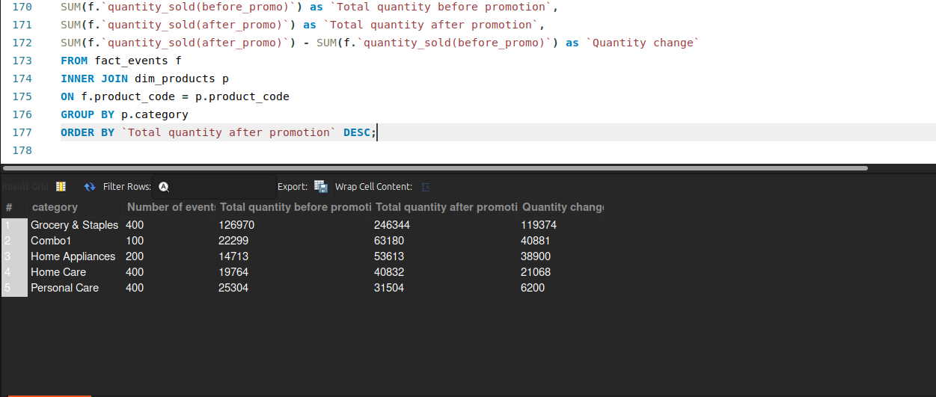

------------------------------------------------------------

Q9. Store Performance
Using fact_events and dim_stores, calculate for every city:

- Number of promotional events
- Total quantity before promotion
- Total quantity after promotion

Display:
- city
- event_count
- total_before
- total_after

Sort cities by total_after descending.

Concepts:
JOIN, GROUP BY, aggregation, ORDER BY.

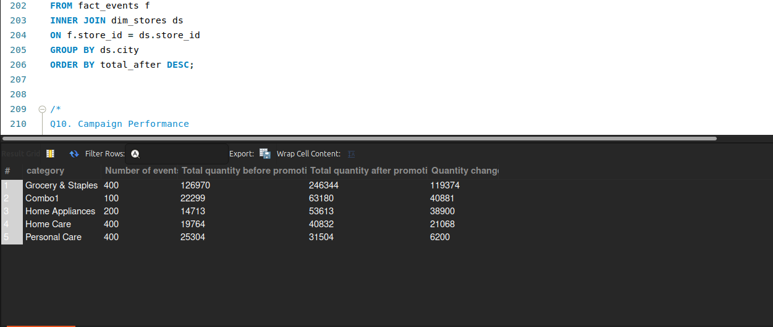

------------------------------------------------------------

Q10. Campaign Performance
Using fact_events and dim_campaigns, calculate for each campaign:

- Campaign name
- Start date
- End date
- Number of events
- Total quantity before promotion
- Total quantity after promotion

Sort by total quantity after promotion descending.

Concepts:
JOIN, GROUP BY, date columns, aggregation.

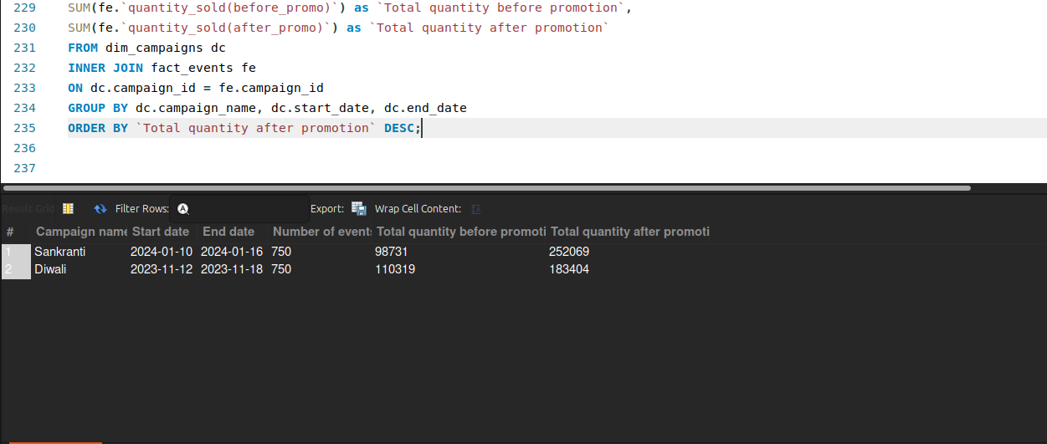

------------------------------------------------------------

Q11. Product Category with HAVING
Find product categories where the total quantity sold after promotion is greater than 1,000.

Display:
- category
- total quantity after promotion
- average base price

Sort by total quantity after promotion descending.

Concepts:
JOIN, GROUP BY, HAVING, AVG, SUM.

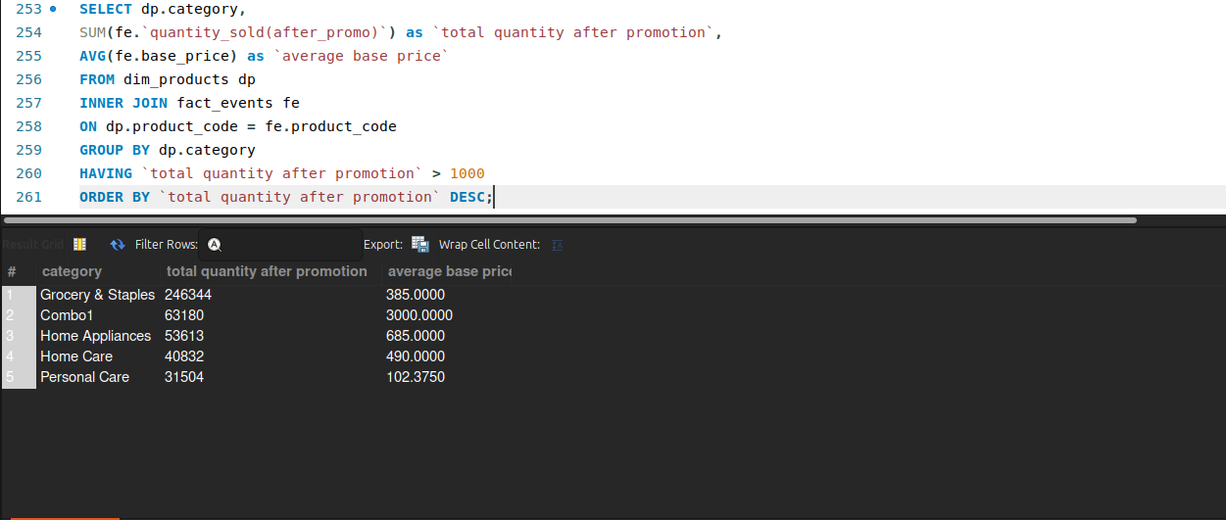
------------------------------------------------------------

Q12. Store + Category Analysis
Using fact_events, dim_stores and dim_products, calculate total quantity sold after promotion for every combination of:

- City
- Product category

Display:
- city
- category
- total quantity after promotion

Sort first by city and then by total quantity descending.

Concepts:
Multiple JOINs, GROUP BY, ORDER BY.
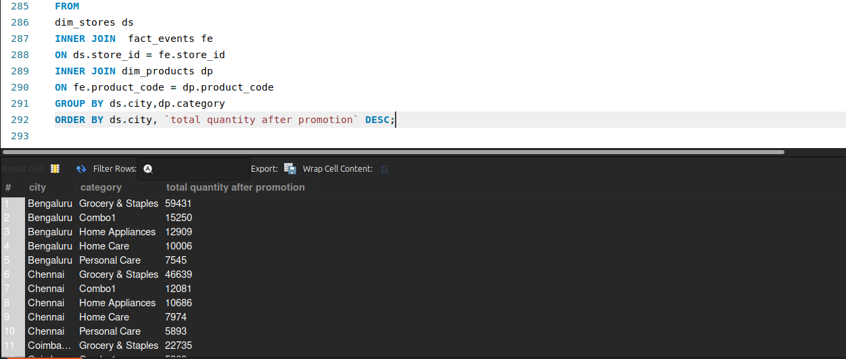
------------------------------------------------------------

Q13. Promotion Effectiveness by Product
For each product, calculate:

- Product name
- Category
- Total quantity before promotion
- Total quantity after promotion
- Quantity change
- Percentage change

Use:

Percentage Change =
((After Promo - Before Promo) / Before Promo) * 100

Handle division by zero appropriately.

Sort by percentage change descending.

Concepts:
JOIN, GROUP BY, arithmetic calculations, NULLIF, percentage calculations.

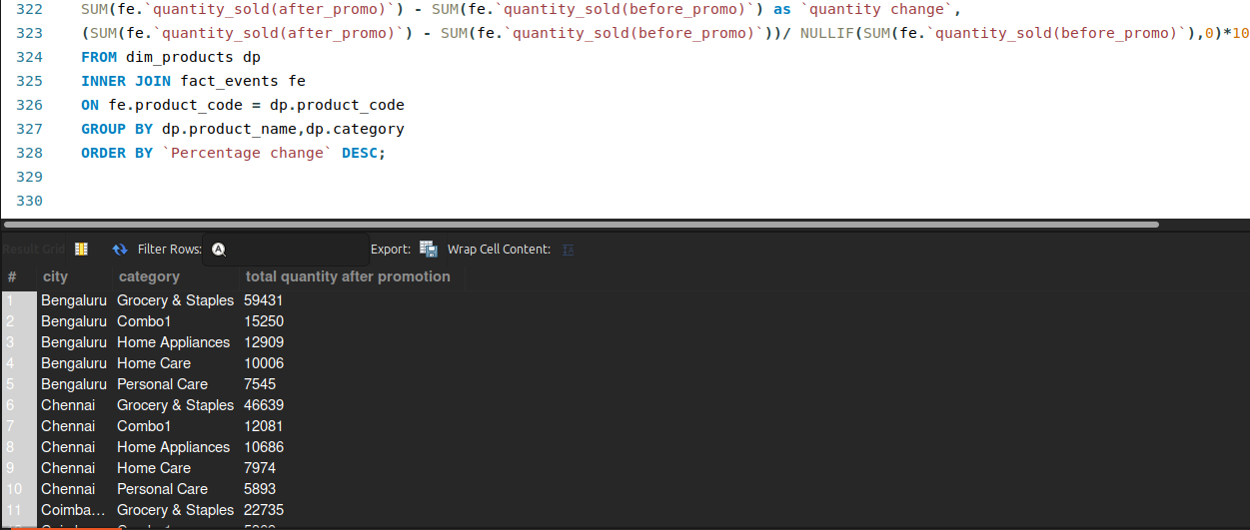
------------------------------------------------------------

Q14. Campaign and Promotion Type Analysis
For each campaign and promo_type combination, calculate:

- Number of events
- Total quantity before promotion
- Total quantity after promotion
- Quantity change

Display:
- campaign_name
- promo_type
- event_count
- total_before
- total_after
- quantity_change

Sort by campaign_name and quantity_change descending.

Concepts:
Multiple GROUP BY columns, JOIN, aggregation, ORDER BY.

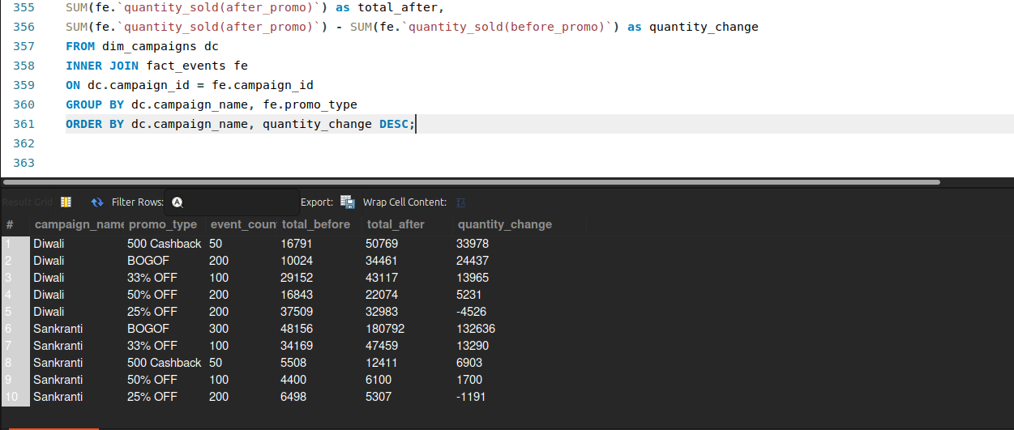
------------------------------------------------------------

Q15. Product Revenue Before and After Promotion
For each product, calculate:

1. Revenue before promotion =
base_price × quantity_sold(before_promo)

2. Revenue after promotion =
base_price × quantity_sold(after_promo)

3. Revenue difference =
Revenue after - Revenue before

Display:
- product_name
- category
- revenue_before
- revenue_after
- revenue_difference

Sort by revenue_difference descending.

Concepts:
JOIN, GROUP BY, SUM, arithmetic calculations, aliases.
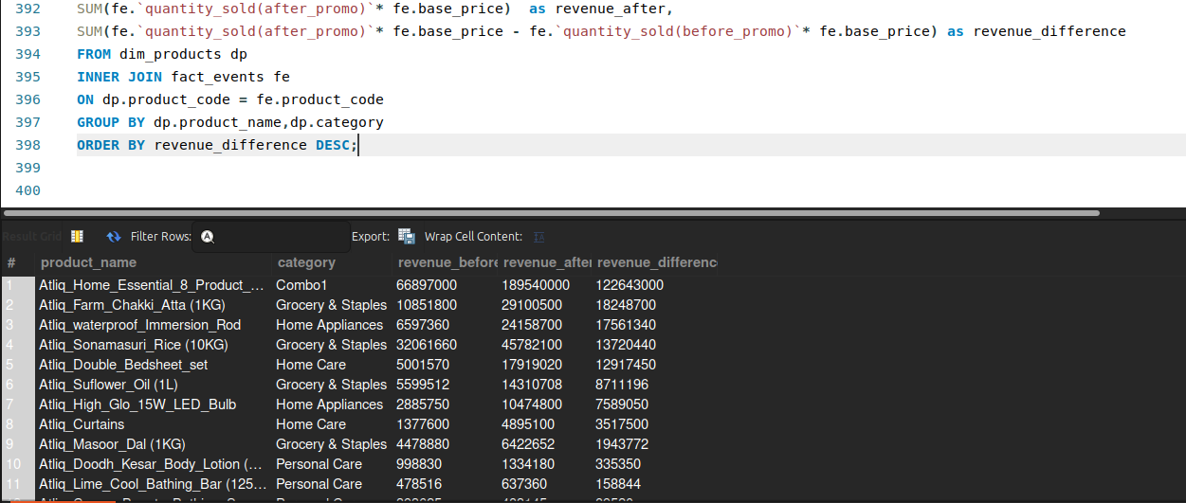

------------------------------------------------------------

Q16. Classify Promotion Performance
For every promotion type, calculate total quantity before and after promotion.

Then classify the promotion using CASE:

- Percentage change >= 50% → "High Impact"
- Percentage change >= 20% → "Medium Impact"
- Percentage change < 20% → "Low Impact"

Display:
- promo_type
- total_before
- total_after
- percentage_change
- performance_category

Sort by percentage_change descending.

Concepts:
GROUP BY, CASE, arithmetic calculations, NULLIF, aliases.

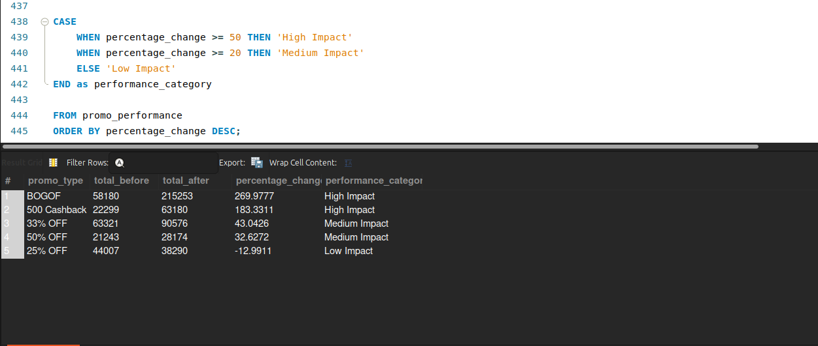

============================================================
HARD QUESTIONS
============================================================

Q17. Top Products Within Each Category
Using a CTE:

1. Calculate total quantity sold after promotion for every product.
2. Rank products within each category based on total quantity sold after promotion.
3. Return only the top 2 products from every category.

Display:
- category
- product_name
- total_quantity_after
- category_rank

Concepts:
CTE, JOIN, GROUP BY, DENSE_RANK/ROW_NUMBER,
PARTITION BY, window functions.

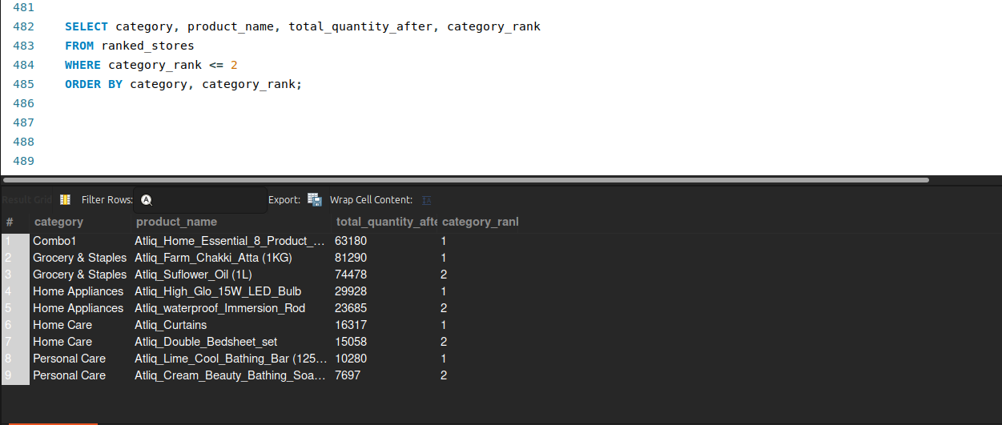
------------------------------------------------------------

Q18. Best-Performing Stores Within Each City
Calculate total quantity sold after promotion for each store.

Join dim_stores to obtain the city.

Then rank stores within each city based on total quantity sold after promotion.

Return the top 2 stores from each city.

Display:
- city
- store_id
- total_quantity_after
- city_rank

Concepts:
JOIN, CTE, GROUP BY, window functions,
PARTITION BY, RANK/DENSE_RANK.

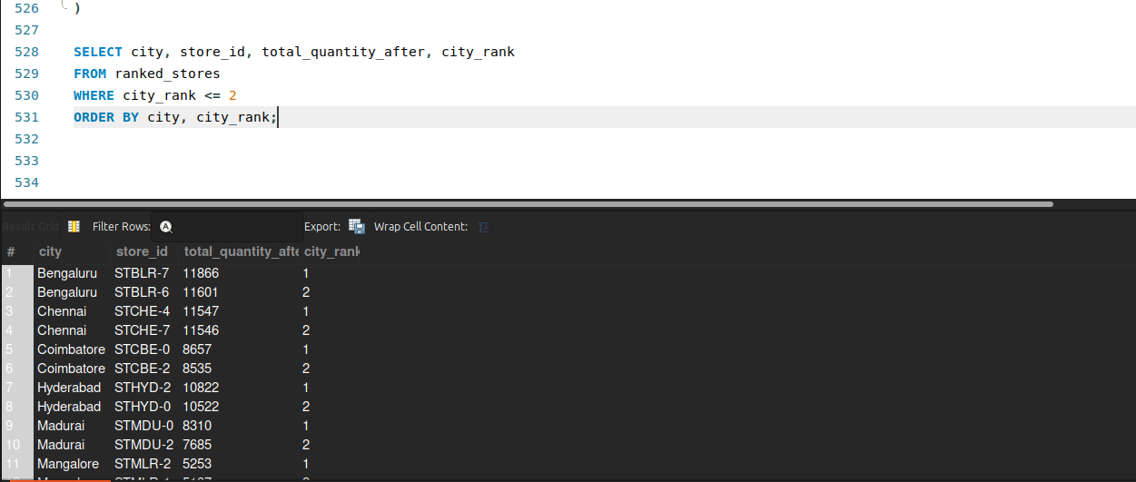

------------------------------------------------------------

Q19. Campaign-Level Product Performance
For every campaign and product:

Calculate:
- Total quantity before promotion
- Total quantity after promotion
- Quantity change
- Percentage change

Then rank products within each campaign based on percentage change.

Return the top 3 products for every campaign.

Display:
- campaign_name
- product_name
- total_before
- total_after
- quantity_change
- percentage_change
- campaign_rank

Concepts:
Multiple JOINs, CTE, GROUP BY, arithmetic calculations,
NULLIF, window functions, PARTITION BY, ranking.

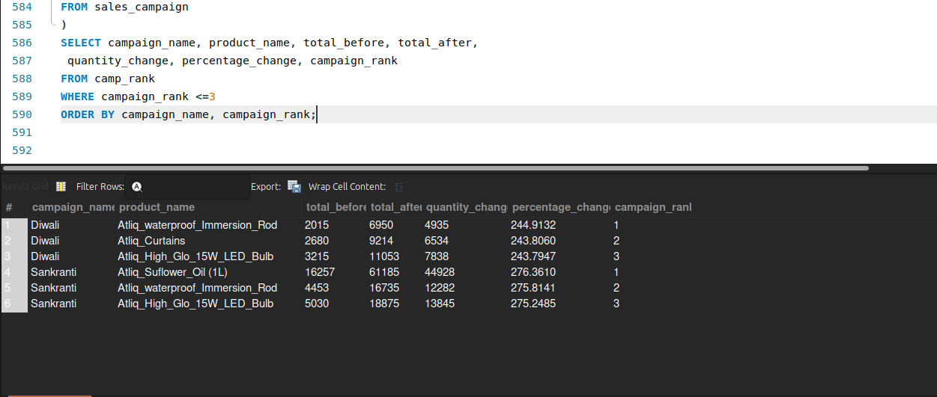

------------------------------------------------------------

Q20. Complete Promotional Performance Analysis
Create a complete analytical report at the product-category level.

For every product, calculate:

- Product name
- Category
- Number of promotional events
- Total quantity before promotion
- Total quantity after promotion
- Quantity change
- Percentage change
- Revenue before promotion
- Revenue after promotion
- Revenue change
- Average base price
- Product rank within its category

Use:

Quantity Change =
Total After - Total Before

Percentage Change =
((Total After - Total Before) / Total Before) * 100

Revenue Before =
SUM(base_price × quantity_before)

Revenue After =
SUM(base_price × quantity_after)

Revenue Change =
Revenue After - Revenue Before

Then:

1. Rank products within each category by Revenue Change.
2. Return only the top 2 products from each category.
3. Use appropriate handling for division by zero.

